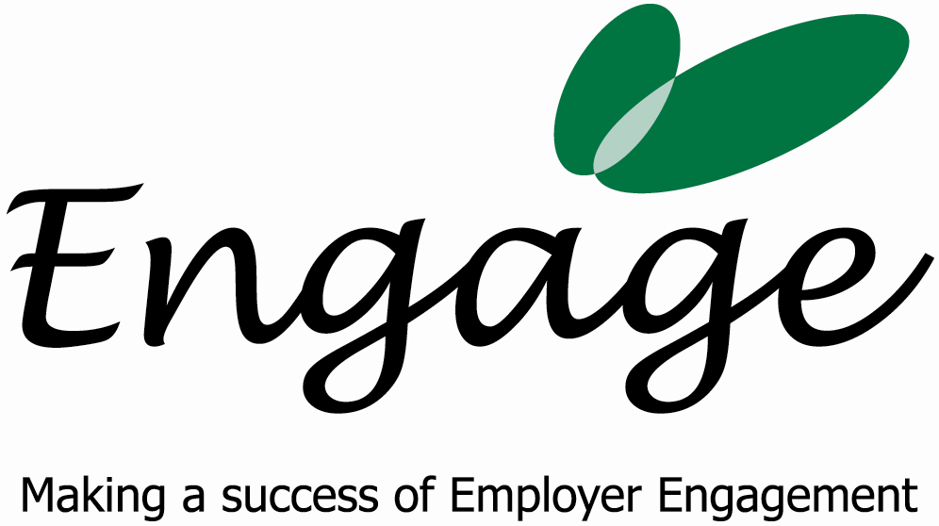

Invoice

Date and Tax Point: 30th August 2007 Invoice Number: 7

Description: 1 day consultancy work for Disability Equals Business on establishing Engage West Sussex

Amount: £550.00

Bank Details:
SMILEMORE the internet bank
Account Number: 70643015 00
Sort Code: 08-92-50

Terms & Conditions

Terms are 30 days from the date of invoice. Late payments will incur a 5% charge.

