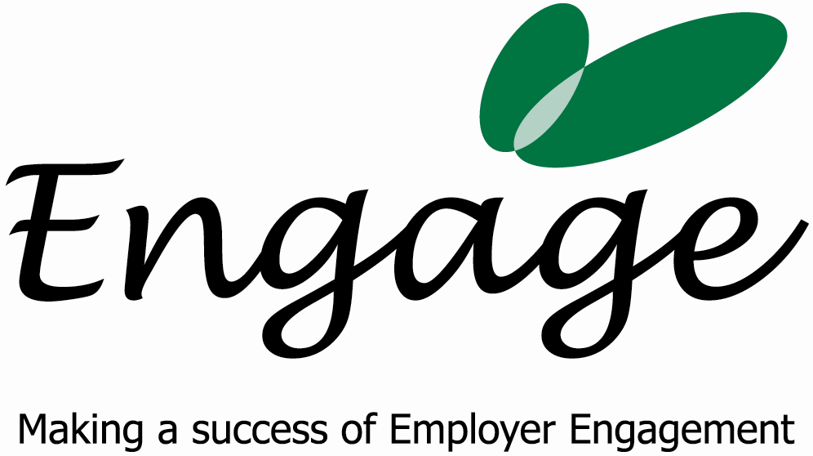

Invoice

Date and Tax Point: 19th & 20th July 2007 Invoice Number: 2

Description: 2 days consultancy work for Disability Equals Business on establishing Engage West Sussex

Amount: £1,100.00

Bank Details:
SMILEMORE the internet bank
Account Number: 70643015 00
Sort Code: 08-92-50

Terms & Conditions

Terms are 30 days from the date of invoice. Late payments will incur a 5% charge.

