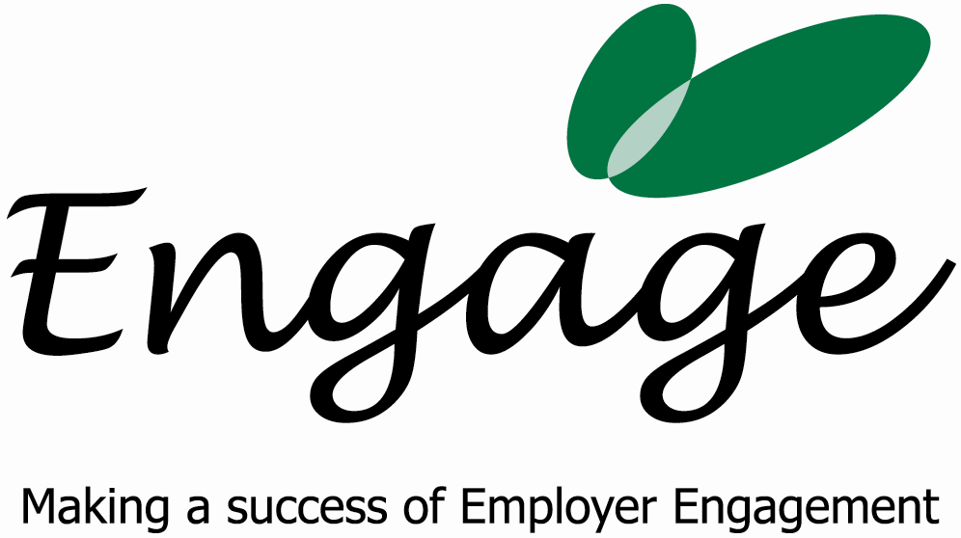 FAO: Lee Townsend
Disability Equals Business
West Sussex County Council
County Hall
West Street
Chichester PO19 1RQ

Invoice

Date and Tax Point: 6th September 2007 Invoice Number: 8

Description: 1 day consultancy work for Disability Equals Business on establishing Engage West Sussex

Amount: £550.00

Bank Details:
SMILEMORE the internet bank
Account Number: 70643015 00
Sort Code: 08-92-50

Terms & Conditions

Terms are 30 days from the date of invoice. Late payments will incur a 5% charge.

