Terms and Conditions 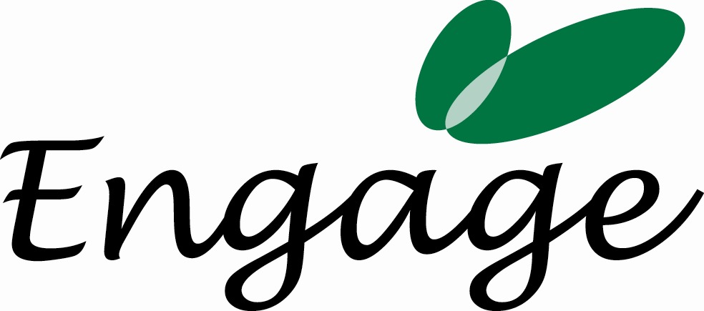

Below are our Terms and Conditions. Please sign and return a copy of this to Engage, Office 2A, 11 Jew Street, Brighton, BN1 1UT. Please note that work may be delayed if this document has not been signed & returned. Engage looks forward to working with you.

Engage | Engage provide expertise consultancy on employer engagement  Address for correspondence is: Office 2A, 11 Jew Street, Brighton, BN1 1UT
Invoices and Payment | Engage will invoice DEB on a monthly basis.  Terms are 30 days from the date of invoice. Late payments will incur a 5% charge.
Cancellation by the DEB | If the project is cancelled by DEB after agreement to proceed has been given, the DEB is liable for 100% of the costs, plus all the costs incurred to that date such as loss of other business.
Cancellation by Engage | Should Engage cancel the activity, then Engage shall be liable for any cancellation charges that DEB incurs up to the value of the contract. Receipts would be required for verification.
Indemnity insurance | Engage will have professional indemnity insurance cover from 1st July and can produce a certificate upon request.
Contingencies | Engage and DEB has complete control of all services given except for events beyond our control such as accidents, delays, strikes, or supply problems.
Confidentiality | Engage will not impart any information, confidential to DEB, to a third party. This obligation will survive termination of this agreement without limitation.

I authorise Engage to undertake the services as per 5th June 2007 and I agree to the Terms & Conditions above:

Name: ___________________________________________________

Organisation: ____________________________________________________

Signature: ___________________________________________________ Date: ___________

