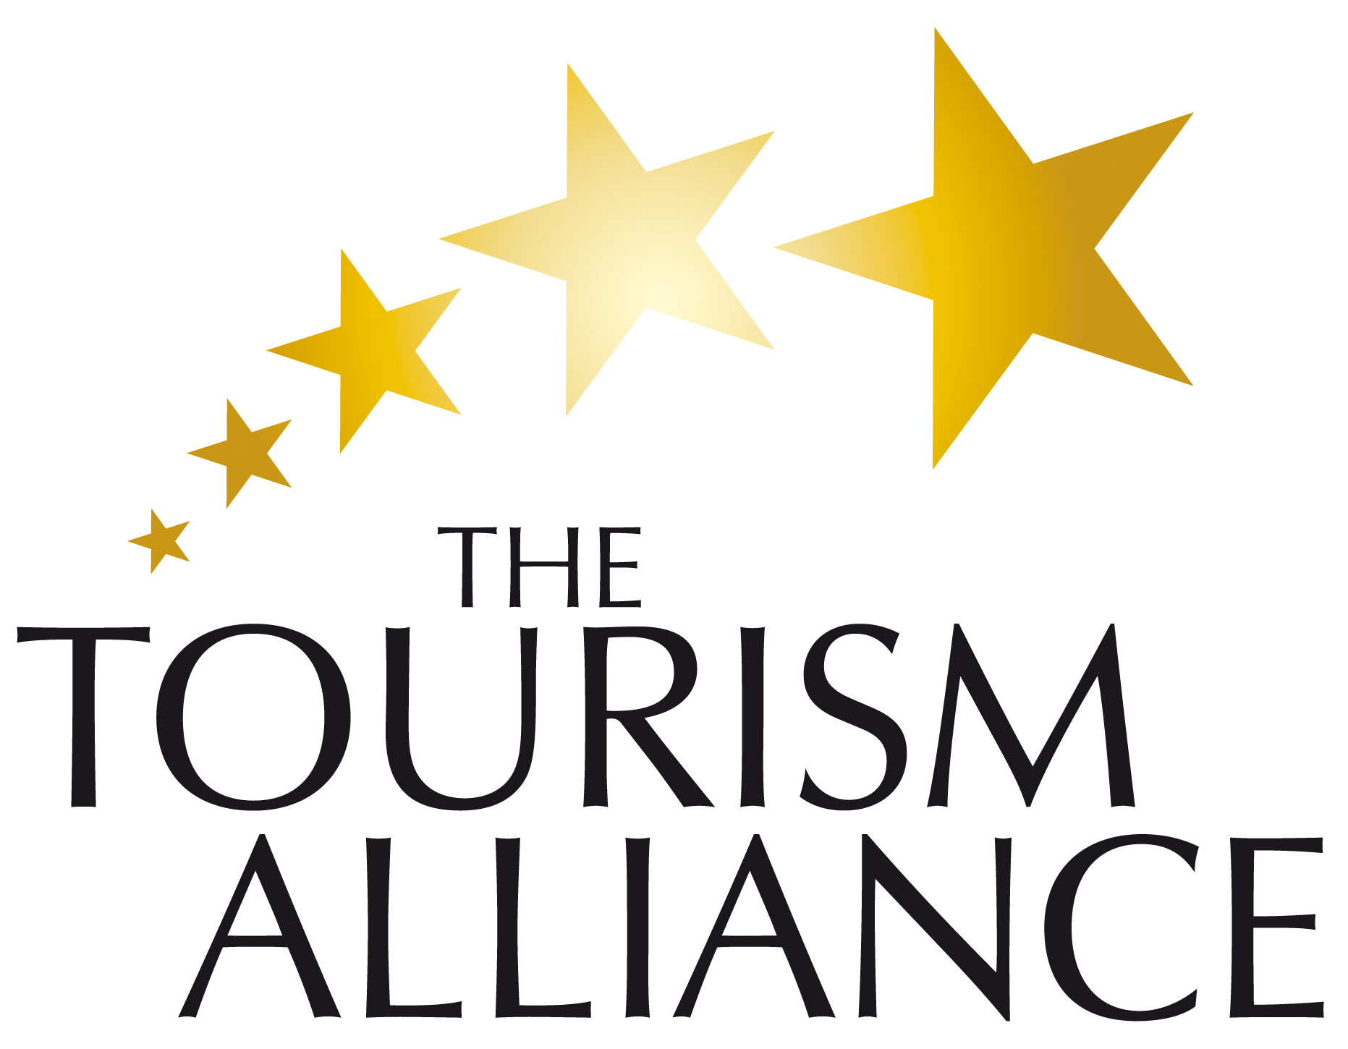
Terms of Reference
December 2009

Mission of the Group
A members only network for any business operating within the Tourism Industry to work alongside other like-minded businesses to formulate projects and initiatives for mutual gain, and the benefit of the wider City economy by:

- Working with each other to maximise our business offers and profitability
- Share best practice to improve the quality of the products and services on offer
- Collaborative working to ensure the protection of the value of the Industry
- Increasing the number of visitors visiting and returning to the City

Objectives
- To provide a forum for collaborative working to improve the visitor experience
- To provide a lobbying group to represent the needs of the tourism industry
- To develop joint profit making initiatives
- To organise or participate in appropriate events that further the mission of the group
- To peer mentor other members where appropriate
- To share skills and experiences to assist other members to make their businesses a success
- To provide a confidential and safe space for members to discuss their businesses

Organisation of the Tourism Alliance
- The Tourism Alliance will officially meet quarterly; members will take responsibility for hosting each meeting and for this will have the opportunity to promote their product or service. Time will be provided during each meeting to share information and to network

- The members will make use of the e-list, tourismfourm@engagesolutions.org.uk to communicate with one another

- Engage Employment Solutions Ltd, Claire Mitchell, will take responsibility for facilitating any peer to peer mentoring or training as members request

- Engage Employment Solutions Ltd, Claire Mitchell, will Chair the meetings and set the agendas, although members of the group will suggest agenda items they wish to be included or have covered. Nick Mosley, Brighton Visitor Magazine, will act as Vice Chair and cover any meetings in the absence of Claire.

- All Group Members must declare, to the Chairman in advance, any direct or indirect interest which may arise in respect of a contract or other matter to which the Group is, or may become involved

Membership
One nominated representative from any business actively engaging with in the Tourism Industry

Any members found to be acting outside the interest of the Group or not upholding the commitments in this document will be removed from the membership. This decision will taken by the members as a whole and executed by Claire Mitchell.

Person Specification for Group
- Nominated General Manager/Owner/ Director with the authority to make decisions which may affect their own business

- To be willing to give time to the Group’s work, including participating in working parties and consultation exercises with colleagues outside the group

Signed Agreement

The content of ALL meetings and emails will be strictly confidential, by signing this Agreement you are committing to upholding this caveat.

This is to confirm that an Agreement is effectively in force and that I will commit to the above mentioned terms and conditions of the Tourism Alliance

Signed:………………………...………………………………

Name: …....…………………….………………………………

Position:…....………………….………………………………

Organisation:.………………..……………………………….

Date:….……………………….……………………………….

