Terms and Conditions 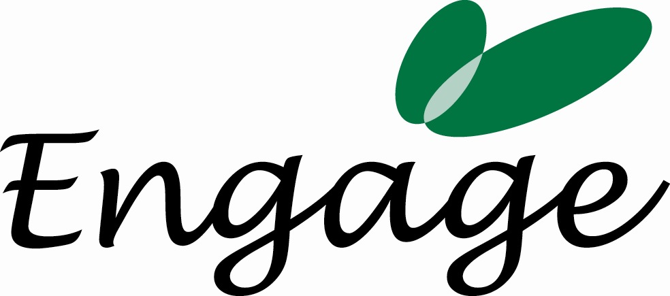

Below are our Terms and Conditions. Please sign and return a copy of this to Engage Employment Solutions Ltd. Please note that work may be delayed if this document has not been signed & returned. Engage looks forward to working with you.

Engage | Engage provide expertise consultancy on employer engagement  Address for correspondence is: 46 Guildford Street, Brighton, BN1 3LS
Invoices and Payment | Engage will invoice City College Brighton & Hove’s SOLD Project immediately. Terms are 30 days from the date of invoice. Late payments will incur a 5% charge.
Cancellation by the SOLD Project | If the project is cancelled by SOLD Project after agreement to proceed has been given, then the SOLD Project is liable for 100% of the costs, plus all the costs incurred to that date such as loss of other business.
Cancellation by Engage | Should Engage cancel the activity, then Engage shall be liable for any cancellation charges that the SOLD Project incurs up to the value of the contract. Receipts would be required for verification.
Contingencies | Engage and SOLD Project has complete control of all services given except for events beyond our control such as accidents, delays, strikes, or supply problems.
Confidentiality | Engage will not impart any information, confidential to SOLD Project, to a third party. This obligation will survive termination of this agreement without limitation.

I authorise Engage to undertake the services as per 18th February 2008 and I agree to the Terms & Conditions above:

Name: ___________________________________________________

Organisation: ____________________________________________________

Signature: ___________________________________________________ Date: ___________

