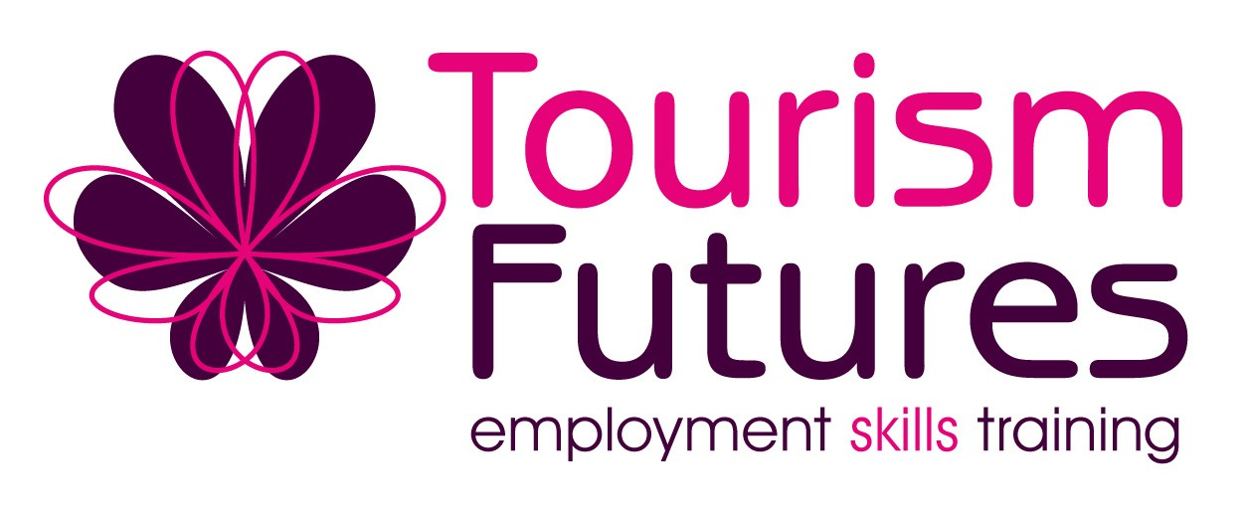

Tourism Futures Charter
How to sign companies up

- Check the Tourism Futures Company spreadsheet to see if we have already made contact. A hard copy can be found in Jill’s in tray. The soft copy is on k:\skills & standards\Tourism Futures\Company spreadsheet folder\Company spreadsheet

- Make contact and explain the charter and it’s benefits:
  - Opportunity to link with like minded businesses, share best working practices etc
  - Chance to network within your sector (at the Forum)
  - Be kept up to date with current training on offer
  - Access to free or subsidised training tailored to your industry
  - Will be visited annually in December to ensure meeting the Charter commitment
  - Etc etc – see Charter for other benefits

- Sign client to the Charter
  - One copy for them
- One copy for us
- One Certificate for them

- Send contact details ASAP to:
  - Naomi/Jill, and
  - Claire Mitchell: Claire.mitchell@engagesolutions.org.uk 07812177427
The information needs to be passed on to keep records up to date. Claire will then make contact and arrange a meeting to ensure new clients maximise their opportunities with the Tourism Forum eg hosting a meeting etc. She will also put their details on the current Tourism Forum website www.engagesolutions.org.uk/Tourism_Forum

THANK YOU!

