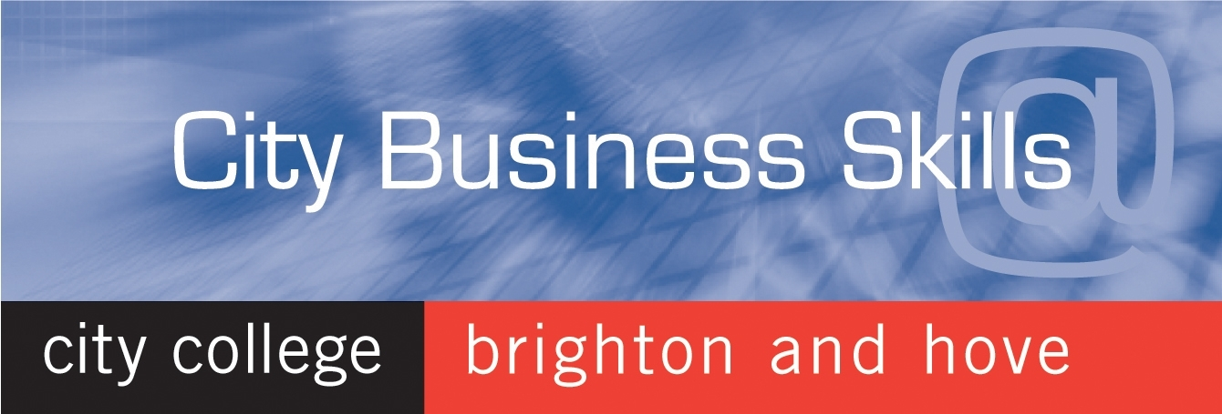

Hospitality Futures Charter
&
City Business Skills @ City College Brighton & Hove

Our pledge is

To help make your business more successful by providing solutions to your
staff training needs.
……….

We will provide one point of contact for you
@ City Business Skills the employer business unit at City College Brighton & Hove.

Contact us by email at: citybusiness@ccb.ac.uk or call us on 01273 667756

………………………………..

City Business Skills provides solution based training for businesses working with local companies through employee sponsorship, apprenticeships and
work -placements across Sussex.
…….....

We will discuss your requirements and provide clear information and signposting for all courses and training solutions available to you.
............
Helping you to make an informed decision on the training programme that
best suits your business.
……….

Please contact us and let us help you grow your business.

……………………………………

