Brighton & Hove City Council

Meeting:

Date: 3 December 2007

Report of: AD Improvement & Organisational Development

Subject: Learning & Development Funding Outline

- Purpose of the report

  - The report sets out an approach for funding learning and development across the council to:

  - Facilitate improvements in individual performance management and development
  - Promote greater consistency and embeddedness of the PDP process
  - Enable the provision of a council-wide ‘training offer’ and competency framework to build workforce capacity

- Recommendations

2.2 To implement a core learning and development programme across the council funded at the level of £500k pa, recurring.

3. Background

  - In its 2006 Corporate Performance Assessment the Audit Commission noted weaknesses in the current approach to learning and development (L&D) which have led inconsistencies in the offer across the Council’s and most important, weaknesses in the individual performance, appraisal and development processes. The inspection concluded that:

“The Council needs to address the management of its human resources. Training and development needs to be improved across the Council. The personal development system, which records development and training needs, is not used in all directorates with less than 50 per cent of assessments completed last year. In turn this limits the completion rate of the Council's team development plans.”

4. Current learning & development provision

  - Total number of training days across the council is currently 10,661 or 2 days per employee. There is not information available in on the level of spend on L&D across B&HCC, but cost is likely to be comparative low due to the large amount delivered in-house. Management of training across the council is devolved to departments, with Housing and CYPT being the largest consumers of training (see also Appendix A).

  - The corporate L&D offer along with monitoring and evaluation are the most under-resourced components of the L&D offer at present. At the time of writing there were over 1,000 training requests outstanding and over 30% of booked training days were not attended. These weaknesses in consistency and compliance are also reflected in generally the low level of PDP completion.

- Benchmarking with other authorities

  - A comparison of 9 London authorities with similar workforce profiles in terms of size and composition is provided in Appendix B. This shows that while there is no single model for organising L&D provision there is a general trend in terms of the level of expenditure and the ability to recharge.

  - Of the nine authorities surveyed, nearly all had a corporate or top-sliced L&D budget, principally to ensure VFM around generic courses. In general, the majority of authorities provided for a corporate L&D budget which average approximately £500k. One half of authorities top-sliced budgets to make up the corporate contribution as well as providing for additional L&D through recharging. Corporate L&D tended to provide approximately one fifth of all training days delivered across councils.

  - A provisional corporate training offer has been detailed in Appendix B which is both comparable both in terms of content and cost at around £433,670 p.a., excluding administration. This represents an increase of 4236 training days or a total of 3 days per employee. This compares modestly with the 4.5 days average across the public sector.

  - While nearly all councils in the sample had some provision delivered in-house, there was some evidence of new and emerging trends. For example, Camden is reviewing its approach to commissioning and delivering training and is exploring potential for shared services with other statutory and voluntary agencies. Hackney recently outsourced all of its L&D delivery to Capita, and there is anecdotal evidence that larger private sector organisations deliver a higher proportion of training in-house to maximise savings (see also Appendix A).

5. Recent trends in L&D

  - Employers identified L&D as being one of the major tools for improving performance and organisational effectiveness. Service based organisations use L&D to improve performance across a range of indicators, including customer services. Many large employers use performance indicators as a measure of L&D effectiveness.

  - The most recent national evidence on training indicates that the average spend on L&D per employee is around £250. While little difference was found between public and private-sector spend on training, the voluntary sector spent significantly more.

  - Appendix C sets out a suggested corporate learning and development programme with indicative costs for development and delivery. As training would delivered on a rolling cycle all costs would be recurring, with the exception of design. With an additional small budget for administration, this would bring the total cost of the corporate programme up to around £500k. To allow for courses to be run on a frequency of more than once per year either a system for recharging (partial or full) would need to be established. Some management development programmes could be funded by the existing £90k Workforce Development budget.

Appendix A

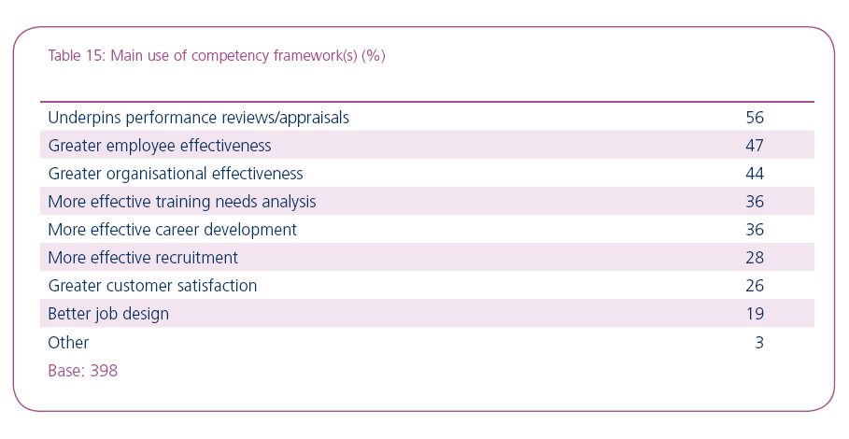

Source CIPD 2007

TRAINING PROVISION IN BRIGHTON & HOVE CITY COUNCIL 2007

 | Training days attended | No staff | Training days not attended | No. of training days not attended ( FIS not included)
Environment | 733 | 959 | 186 | 152
Housing & City Support | 5660 | 1546 | 2344 | 2269
Finance & Resources | 570 | 693 | 140 | 116
CYPT | 2204 | 1068 | 707 | 654
Cultural Services | 268 | 465 | 95 | 87
Strategy & Governance | 201 | 230 | 44 | 16
Customer Services | 1025 | 330
Totals | 10661 |  | 3542 (206) | 3294

Appendix B - Comparative And Best Practice Information.
 | CPA Rating | 2004/05 spend on corporate training (£) | Training Facilities | Funding model | # of staff (excluding teachers) | # corporate training days
Camden | Excellent | 2.5m (All) | No dedicated L&D training resource outside of Teacher Training Centre | Devolved to depts | 6,500 | 30,000 (All)
K&C | Excellent | N/A | Corporate Learning Centre, Teacher Training Centre & others. |  |  | 7,485 (average 2.89 days pa)
Southwark | Good | 574,000 | Corporate Learning Centre, no Teacher Training Centre | Recharged to depts | 5265 | 4,389
Greenwich | Good | 572,000 | No dedicated corporate facility, Teacher Training Centre & others | Top sliced | 6400 | N/A
Islington | Good | N/A | No dedicated corporate facility, Teacher Training & others | Recharged to depts | 2758.19 (FTE) | 13,791 (All)  Based on 5 L&D days a year
Lewisham | Good | 372,000 | No dedicated corporate facility, Teacher Training Centre & others | Top sliced | 8,500 | 2,957
Haringey | Fair | 584,000 | Corporate Learning Centre, Teacher Training Centre & others | Top sliced | 8180* | Not available
Hackney | Weak | 300,000 | No dedicated corporate facility, Teacher Training Centre & others | Recharged to depts | 3300 | Not available
Lambeth | Weak | 600,000 | No dedicated corporate facility, Teacher Training Centre & others | Set budget + dept recharge | 4000 | Not available

APPENDIX C

CORPORATE LEARNING & DEVELOPMENT OFFER

Management Development Programme | Design | Delivery | Venue | Catering | No of days training | Courses pa | No of Delegates | Total Cost
HR Policies and procedures | £650 | £650 | £200 | £150 | 1 | 12 | 144 | £12,650
Absence Management | £650 | £650 | £200 | £150 | 1 | 12 | 144 | £12,650
Discipline and Capability | £650 | £650 | £200 | £150 | 1 | 13 | 156 | £13,650
Recruitment and Selection | £1,300 | £1,300 | £400 | £150 | 2 | 12 | 144 | £23,500
Managing a Diverse Workforce | £650 | £650 | £200 | £150 | 1 | 12 | 144 | £12,650
H&S Management System | £650 | £650 | £100 | £150 | 1 | 12 | 144 | £11,450
Managing Budgets | £650 | £650 | £100 | £150 | 1 | 12 | 144 | £11,450
Managing Procurement | £650 | £650 | £100 | £150 | 1 | 12 | 144 | £11,450
Managing Performance (PDPS) | £1,300 | £650 | £200 | £150 | 1 | 12 | 144 | £13,300
Team Planning System and Performance Measurement | £650 | £650 | £100 | £150 | 1 | 12 | 144 | £11,450
Managing a Sustainable Service | £650 | £650 | £200 | £150 | 1 | 12 | 144 | £12,650
Leadership Workshop (whats expected of BHCC managers) | £1,300 | £975 | £300 | £200 | 1.5 | 12 | 144 | £19,000
Building High Performing Teams | £3,900 | £1,625 | £500 | £300 | 2.5 | 12 | 144 | £33,000
Manager as a Coach | £1,300 | £975 | £300 | £180 | 1.5 | 12 | 144 | £18,760
Facilitation Skills | £1,300 | £975 | £300 | £180 | 1.5 | 12 | 144 | £18,760
Managing and Motivating | £1,300 | £975 | £300 | £180 | 1.5 | 12 | 144 | £18,760
Transparent communication | £1,300 | £1,300 | £400 | £240 | 2 | 12 | 144 | £24,580
Manager as a Change agent | £1,300 | £975 | £300 | £180 | 1.5 | 12 | 144 | £18,760
Political Awareness | £650 | £650 | £200 | £15 | 1 | 12 | 144 | £11,030
Working in a Unionised Environment | £650 | £650 | £200 | £15 | 1 | 12 | 144 | £11,030
Project Management | £650 | £650 | £200 | £15 | 1 | 12 | 144 | £11,030
Service Planning and Performance Management | £650 | £650 | £200 | £15 | 1 | 12 | 144 | £11,030
Managing ICT | £650 | £650 | £200 | £15 | 1 | 12 | 144 | £11,030
Total | ##### | ##### | #### | £3,185 |  | 277 | 3,324 | £353,620
Core Skills Programme | Design | Delivery | Venue | Catering | No of days training | No of  annual  sessions | No of Delegates | Total Cost
Council Induction (Welcome Day) | £650 | £0 | £200 | £150 | 1 | 12 | 240 | £4,850
Interviewee Skills | £650 | £650 | £200 | £150 | 1 | 12 | 144 | £12,650
Peformance and Development Planning Scheme - taking part | £650 | £650 | £200 | £150 | 1 | 12 | 144 | £12,650
Letter & Report Writing Skills (Business Communications) | £650 | £650 | £200 | £150 | 1 | 6 | 72 | £6,650
Note Taking & Writing Minutes | £650 | £650 | £200 | £150 | 1 | 6 | 72 | £6,650
Introduction to Presentation Skills | £650 | £1,300 | £400 | £300 | 2 | 6 | 72 | £12,650
Retirement Planning | £650 | £1,300 | £400 | £300 | 2 | 4 | 48 | £8,650
Train the Trainer | £650 | £1,300 | £400 | £300 | 2 | 4 | 48 | £8,650
Effective Communication (Giving & receiving feedback) | £650 | £650 | £200 | £150 | 1 | 6 | 72 | £6,650
Total | £5,850 | £7,150 | #### | £1,800 |  | 68 | 912 | £80,050
 | ##### | ##### | #### | £4,985 |  |  | 4,236 | £433,670

As some spend data included training room and venue costs it is difficult to disaggregate spend on training days from all training activity
Learning & Development Survey, CIPD April 2007.

