Richard Braid AKA “Braidy” for outstanding carpentry work
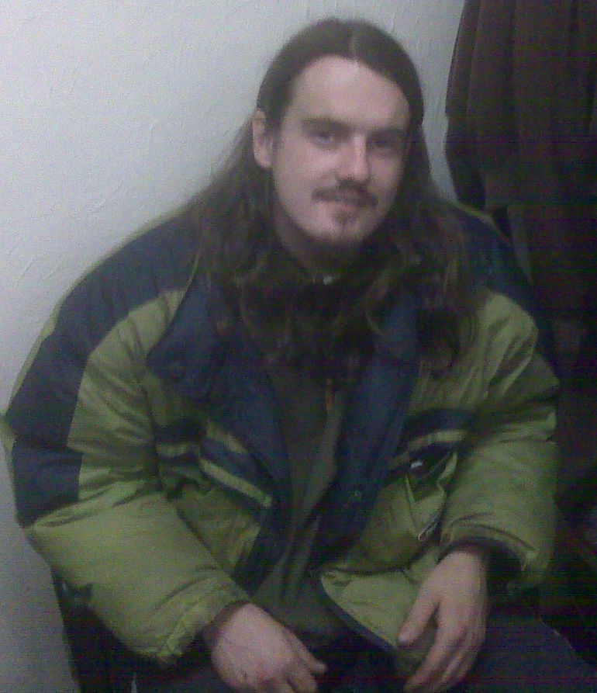

Warning! If YOU give this man A JOB he could seriously improve your working life……..

- He is a quick worker with a solid reputation for working hard
- He is reliable
- He is good at problem solving and coming up with innovative solutions
- He works well alone or in a team

To meet the man himself please ask either Christian at the Wood Recycling Project or contact Claire on 07812 177427…..

