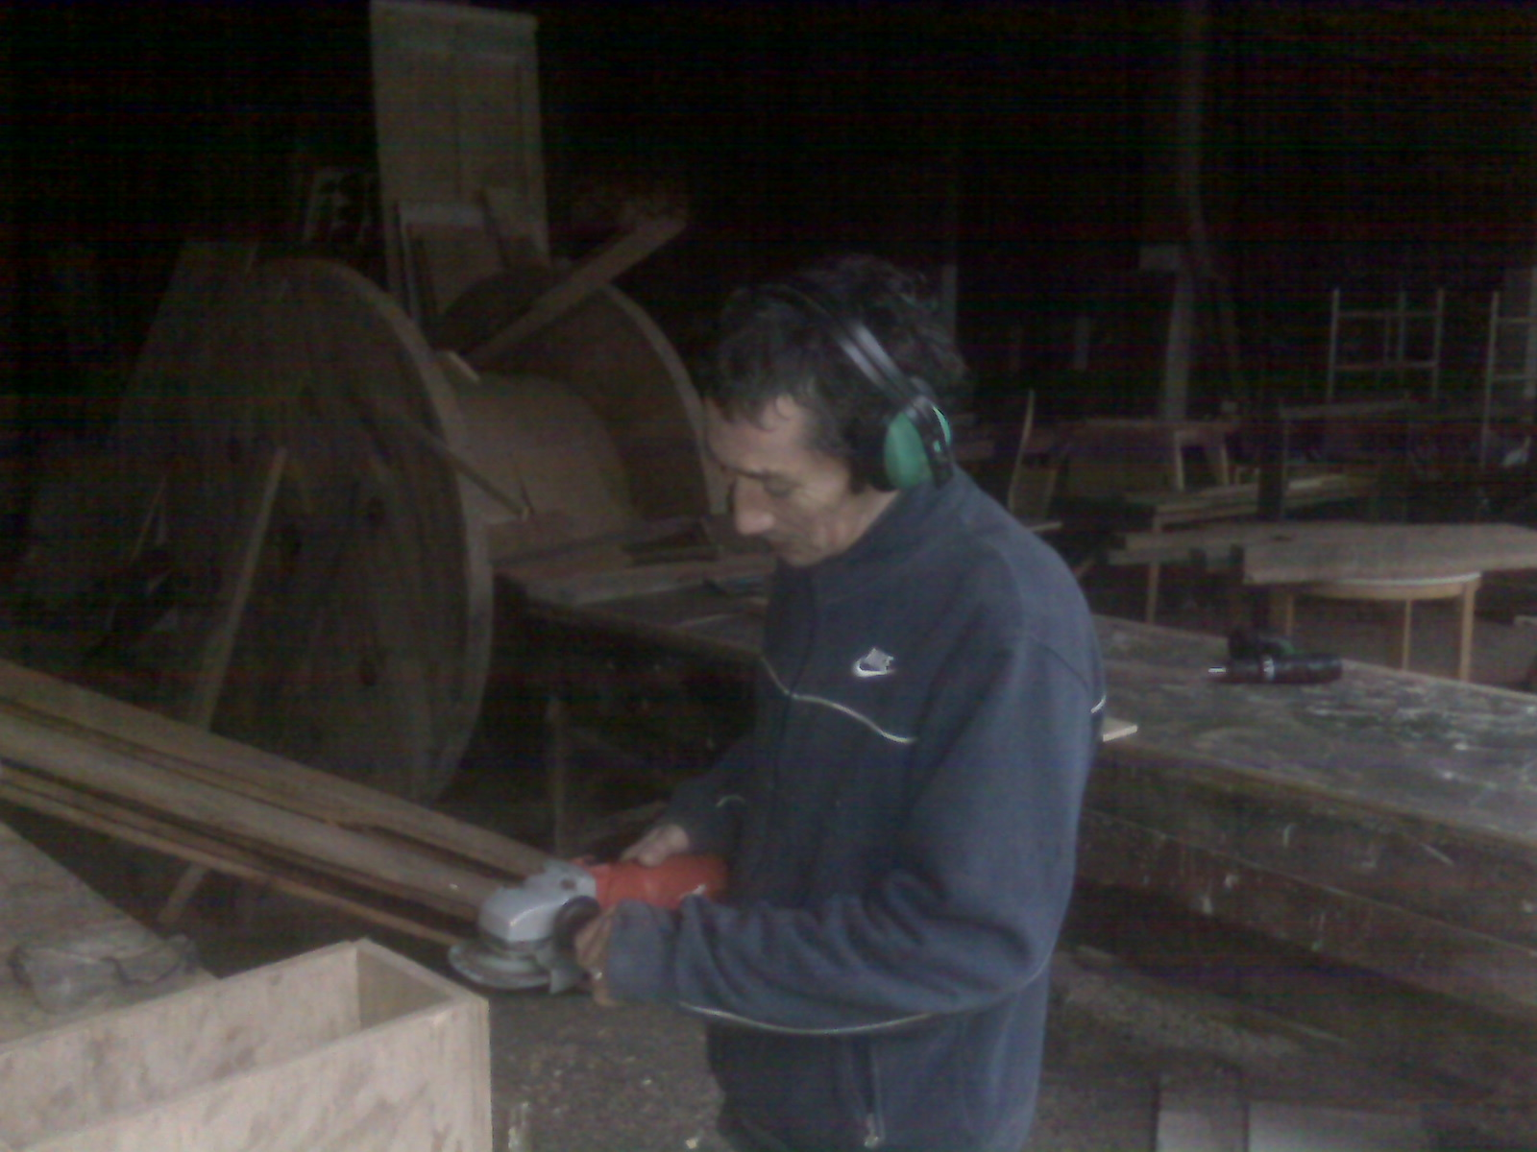

This polite gent is looking for practical work, ideally in landscape gardening, but is interested in ANY outside work.

- He works hard
- Is good at problem solving, always remaining calm in the face of adversity
- Is always on time and can be relied upon
- Makes a great addition to any team, big or small

