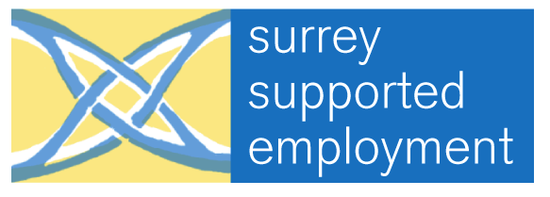

SURREY SUPPORTED EMPLOYMENT
SEMINAR

Tuesday 21st November
at the
Runnymede Centre, Chertsey Road, Cherstey, Surrey

9.45 am | Registration and Refreshments
10.15am | Welcome and Introductions  Sue Godby  Chair of Surrey Supported Employment
10.25am | Surrey @ Work  Henry Woodhall  Surrey Supported Employment
11.15am | Tea & Coffee
11.35am | Knowing Your Rights  Zem Rodaway  Disability Rights Commission
12.35 pm | Open Session  David Barrett  Surrey Supported Employment
1.00 pm | Lunch and Networking
2.00 pm | Getting Through the Door  Hedley Finn
3.00 pm | Tea & Coffee
3.15 pm | Supported Employment - A model for all  Karl Burgess  EmployAbility
4.15 pm | Seminar Ends
Seminar Administration: David Barrett – SSE Company and Network Secretary
& Carol McCart – Administration Officer EmployAbility

