SCIP LEARNING

Communication skills in your community

Mail Merge with Office 2000 and Office XP

Workshop


Anne Stafford - Learning & Outreach Coordinator
t| 01273 234049 e| anne@scip.org.uk w| www.scip.org.uk
SCIP, Community Base, 113 Queens Road, Brighton BN1 3XG

What is Mail Merge?

Mail-Merge is used when you wish to send the same letter to lots of people.

The Theory

A mail-merge always involves three steps

- Creating the Data Document – which contains all the personal information that will change from letter to letter. e.g. the address and the name
- Creating the Main Document – which is the letter you are sending
- Merging the Data Document and the Main Document into individual letters

The Data Document
- The data document is laid out in a table
- In the columns of the table are the fields, or the types of information that will change from letter to letter. The field names are held in the first row
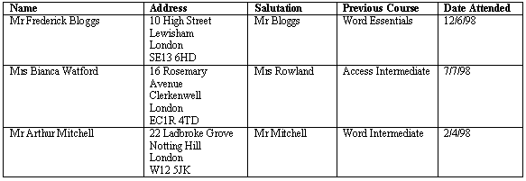
- In the subsequent rows are the records, or the information that will show on each of the letters
Field names are held in the first row
Records are held in subsequent rows

The Main Document
- The main document contains all the standard text which will not change between letters

- At the point where information will change, a merge field has been inserted, to indicate to Word, that it must find the required information in the data document
The merge fields appear in brackets, and correspond to the field names in the data document
Creating your Data Document

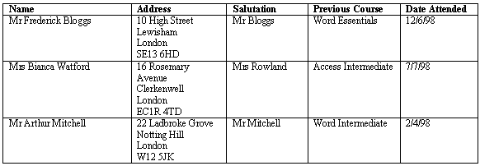
How Will the Data Document Look?

The data document will be laid out in a table, with the field names in the top row

Creating the Data Document
- Start a new document
- Create a table
The number of columns = the number of fields
The number of rows = the number of records + 1 (for the field names)
- Type your field names into the first row
- Type your records into the subsequent rows
- Save the data document
- Close the data document
How should the address be laid out?
Enter the address as it will be laid out on the letter, e.g. with hard returns after each line

Creating a Main Document

How Will the Main Document Look?

The main document will look exactly like a normal letter, except at the points where information needs to be retrieved from the data document, where you will see merge fields.
Merge fields are enclosed in brackets

Creating the Main Document
- Start a new document
- Type all of your standard text as normal
- Click on Tools
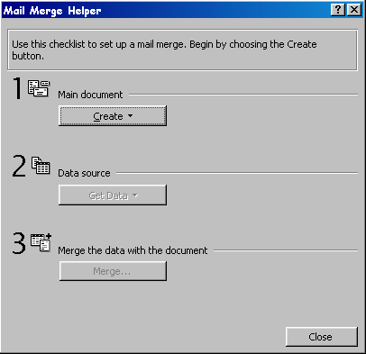
- Click on Mail Merge
- Click on Create
- Click on Form Letters
- Click on Active Window from the dialog box that appears
- Click on Get Data
- Click on Open Data Source
- Change the “Look In” box to the folder where your data document is saved
- Select your data document
- Click on Open
- Click on Edit Main Document from the dialog box which appears

Inserting Merge Fields into your Main Document

Once you have created your Main Document, a new toolbar will appear on the screen

This is the mail-merge toolbar. You can use it to insert your merge fields into the main document.

- Position the cursor where you require your first merge field (e.g. the name or address)
- Click on Insert Merge Field
- Click on the name of the field you require
- Repeat steps 1-3 until all your merge fields are inserted

Remember to include spaces around the merge fields
The letters will be laid out exactly the same as your main document, If there is no space between your merge fields and the standard text, then the words will run into each other!

Inserting the Date
- Position the cursor where you require the date
- Click on Insert
- Click on Date and Time
- Click on the style of date you require
- Click OK
Carrying Out a Mail Merge

Previewing Before You Merge
Before you actually carry out the merge, you can preview it to see how your letters look. This often reveals small mistakes and can save time later.

- Make sure you are in the main document
- Click on the View Merged Data icon
- Click on the record navigation icons to move through your letters
Moves to last record
Moves to next record
Moves to previous record
Moves to first record
- Click on View Merged Data icon again when you have finished

If there are mistakes in your main document, correct them now. If there are mistakes in your data document…
- Click on edit data source icon
- Click on View Source
- Make your changes to the table
- Click on Mail Merge main document when you have finished
or
Save and close the data document

Merging With the Document On-Screen
Click on the merge to new document icon
A new document containing your letters is created on the screen.
Each letter will start on a new page

Printing Merged Documents

Click on the merge to printer icon

Never save a merged document
Saving merged documents wastes space on your computer. As long as you have your main document and your data document you can just do the merge again when you require the same letters

Merging Selected Records
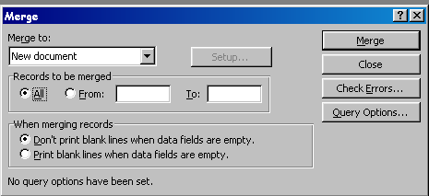
- Click on Merge
- Click in the circle next to From
- Type in the number of the first record you wish to merge
- Click in the box next to “To”
- Type in the number of the last record you wish to merge

Mail-Merge to Labels
Creating a Data Document for Labels
You can use the same data source for your labels as you used for your letters, as long as it contains fields for the name and address!

Creating the Main Document
- Start a new document
- Click on Tools
- Click on Mail Merge
- Click on Create
- Click on Mailing Labels
- Click on Active Window from the dialog box that appears
- Click on Get Data
- Click on Open Data Source
- Change the “Look In” box to the folder where your data document is saved
- Click on Open
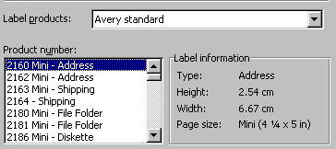
- Click on Set up Main Document
- Change the “Label products” box to your label manufacturer
- Choose the product number
- Click OK
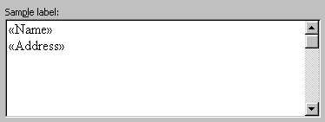
- Click on Insert Merge Field to add your fields (as below)
- Click OK
- Click Close

Carrying out the merge
Click on merge to new document to create a new document containing your labels
or
Click on merge to printer to print the labels

Merging Selected Records
- Click on Merge
- Click in the circle next to From
- Type in the number of the first record you wish to merge
- Click in the box next to “To”
- Type in the number of the last record you wish to merge
Query Options in a Mail Merge

Sorting Records
- Open your main document
- Click on Tools
- Click on Mail Merge
- Click on Query Options
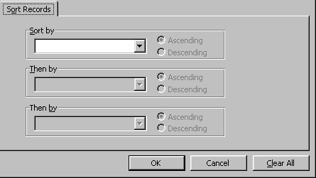
- Click on Sort Records tab
- Click on the down arrow under “Sort by”
- Click on the first field you wish to sort
- If required, click on the down arrow under “Then by”
- Click on the second field you wish to sort
- Click OK
- Click on Merge
- Click on Merge

Extracting Records to Merge
- Open your main document
- Click on Tools
- Click on Mail Merge
- Click on Query Options
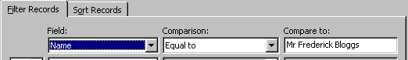
- Click on the Filter Records tab
- Click on the down arrow under field
- Click on the field you wish to extract from
- Click on the down arrow under comparison
- Click on the comparison required
- Click in the “Compare to” box
- Type in what you are looking for
- Click OK
- Click on Merge
- Click on Merge

Extracting Records on More Than One Criteria
When you extract records on more than one criteria, you must specify whether you are using AND or OR. For example, my two criteria are female and finance department.
- AND will give you records that meet BOTH of your criteria. So I will get all the females who work in the finance department.
- OR will give you records that meet EITHER of your criteria. So I will get all the females, and all the people who work in the finance department.

e.g. merging the records of people who work in finance and are female

- Click on Tools
- Click on Mail Merge
- Click on Query Options
- Click on the Filter Records tab
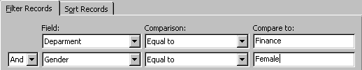
- Set the fields and comparisons as required (see below)
Choose “And” or “Or” here
- Click OK
- Click on Merge
- Click on Merge


If you have set query options before
Click on clear all in the query options dialog box to clear all your previous settings

Trouble-Shooting Mail Merge

Error message “Word could not open data as a data or header source because it is a mail merge main document”
Somehow or other, the data document has become a mail merge main document. To rectify this error…

- Open the data document
- Click on Tools
- Click on Mail Merge
- Click on Create
- Click on Restore to Normal Word Document
- Click Yes
- Click Close
- Save the data document
- Close the data document
- Try the mail-merge again!

When I Click “Insert Merge Field” my Field Names Do Not Appear
- Open your data document
- Make sure that the first row of your table contains the field names
- Make sure that there are no hard returns or text above your table
- Click Save
- Close the data document
- Try the mail-merge again!

Word Tells Me There Are No Field Delimiters in My Data Source
This means that there is text above the table. Word always expects to find the field names in a table at the very top of the document. If there is text or spaces above the table, you will get this error message

- Open the data document
- Delete all spaces and text above the table
- Make sure that the table is at the very top of the document and that the first row contains the field names
- Save the data document
- Close the data document
- Try the mail-merge again!

Notes

