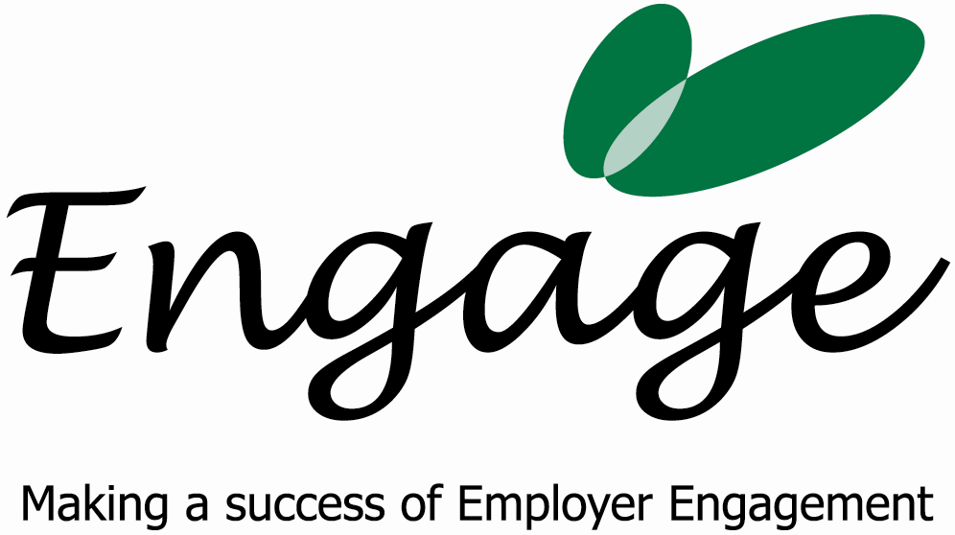

Recruitment – removing the risk and reaping the rewards

Recent business reports highlight a real problem recruiting staff with the right skills, especially at management level.

Now, there is a low risk, no cost solution in Brighton and Hove that not only benefits your current employees but also the community at large, and there isn’t a catch!

It works by matching the unemployed, who have gone through a pre-employment programme, to local businesses. And the business can get extra staff without the financial cost.

A work placement is generally unpaid and can last from anything from two weeks to six months, depending from which agency the client is referred.

Involvement in the initiative often brings free publicity and the opportunity to apply for a CommunityMark kitemark (please visit www.bhbcp.org.uk).

Brighton & Hove's economy is dominated by SMEs, of which there are only 8,500 VAT registered businesses. Unemployment is high - twice the region’s average; more than 30% of the city’s 16-74 yr olds are economically inactive.

“Without businesses offering work placements we have no way of supporting people to get the right skills to find paid for work,” says Claire Mitchell of Engage.

“We’re talking about people with either no confidence to apply for work independently, people who suffer prejudice because of their appearance or disability and those who have had the wrong skills for work in a specific area.

“These people are extremely motivated to work, make very loyal employees and have generally proven to have better sickness records than employees recruited using more conventional routes.”

To find out more and have a ‘no strings attached’ chat please contact Claire Mitchell on 01273 291683 or e mail her: claire.mitchell@engagesolutions.org.uk

