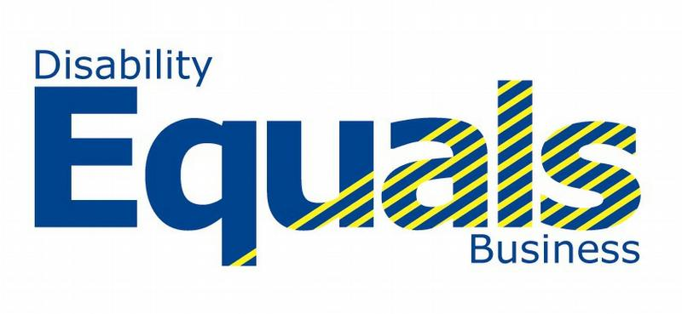

The Final and Fabulous DEB Not So Trivia Quiz!

First things first, please write your team name here:

___________________________________________________________

How many people are in your team? __________

Please circle what you believe, as a group, is the correct answer to each question below.

- Which famous Hollywood actor had this to say about his dyslexia?
“I had to train myself to focus my attention. I became very visual and learned how to create mental images in order to comprehend what I read.”

Brad Pitt Tom Cruise Bruce Willis

- According to the Disability Rights Commission, how many people of working age in Britain are considered by the government to be “disabled”?

1 in 5 1 in 10 1 in 20

- What nationality is the athlete Oscar Pistorius, the double amputee world record holder in 100m, 200m and 400m: and 2004 Olympic 200m champion?

South African Australian Polish

- Which British Prime Minister famously referred to their depression as their ‘black dog’?

Harold Macmillan Harold Wilson Winston Churchill

- According to research from the DWP what is the spending power of disabled people in the UK estimated at?

£10 million £70 million £80 billion
- According to the 2005 Labour Force Survey, what percentage of people over the age of 65 have a “disability”?

22% 32% 42%

- According to estimates by Churchill Minty & Friend, how much money per employee can employers save through improving the retention of valued employees who become disabled?

£30,000 – £70,000 £40, 000 – £100,000 £80,000 – £150,000

- According to the Employers Forum on Disability approximately how many countries worldwide have disability discrimination law?

25 75 105

- According to a survey carried out by the Employers Forum on Disability what percentage of the disabled people surveyed in 2005, were unable or unwilling to make a purchase from a business because it was inaccessible and/or had an unwelcoming attitude?

66% 83% 88 %

- Where can disabled employees get advice and funding for reasonable adjustments to enable them to work more effectively?

Access to Work
Disability Rights Commission
Employers Forum on Disability

THE END!

A member of the DEB team will mark your team’s quiz sheet during the afternoon workshops and we promise faithfully that they are independent and impartial! If there is more than one winning team, the final winning team will be the one with the team name judged, by the DEB Conference speakers, to be the most original and entertaining!

