Thursday, 30 July 2026

Dear Claire

Thank you very much for your kind donation to help me reach my Kilimanjaro Fundraising Target.

This unique challenge will make the Enham team the first multi-ability British team to climb and descend Mount Kilimanjaro. The Team comprises of nine disabled and nine non-disabled adults climbing together in a unique buddying system. The training has started with a vengeance and everyone is meeting up regularly to get to know each other in preparation.

I am deeply touched and so excited about Engage sponsoring me. I have already attached your logo to all of my outgoing letters and Kilimanjaro marketing materials.

Along with my buddy, Jamie, we are both extremely excited about the climb, a climb that is only possible following the support of generous people like yourselves and we really are grateful.

Sending renewed thanks and best wishes.

Yours sincerely

Michael

Michael Steel

The Enham Kilimanjaro Challenge
www.justgiving.com/michaelsteel

Partnership Liaison Co-Ordinator
Enham Employment Services
Eastleigh Community Enterprise Centre
Unit 3, Barton Park Ind. Estate
Eastleigh
Hampshire
SO50 6RR
T: 023 80687710
F: 023 80687714
E: michael-steel@enham.org.uk
www.enham.org.uk

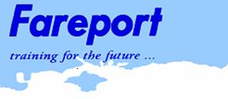

Fareport Training is sponsoring me to climb Mount Kilimanjaro.
www.fareport.co.uk

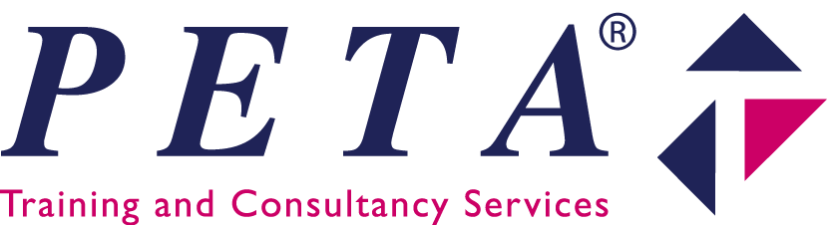

Peta Ltd is sponsoring me to climb Mount Kilimanjaro.
www.peta.co.uk

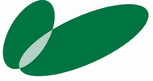

Engage Solutions is sponsoring me to climb Mount Kilimanjaro.
www.engagesolutions.org.uk

'I am pleased to be personally supporting Michael with this fantastic challenge and wish all at Enham the very best with climbing Mount Kilimanjaro and for the future.' - Fred Dinenage, ITV.

