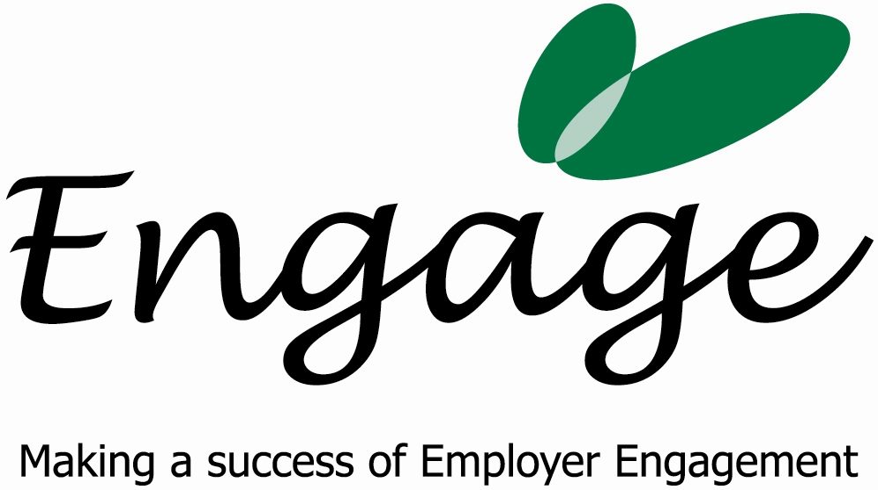

PLACEMENT AGREEMENT

Although the placement is unpaid and voluntary, Engage Employment Solutions Ltd will require you to follow the company’s policies and procedures.

Engage will agree to:
- Provide a work placement and on the job training and support
- If you desire it, design and agree with you a Personal Development Plan (PDP), which will detail the scope and content of the placement. Where possible, Engage will try to fit your personal development needs with those of the business, to enable you to make progress and develop your employability skills
- Review your progress and provide feedback
- Provide advice and coaching in job seeking within the City

As a volunteer you must agree to:
- Abide by the rules and regulations of Engage, as instructed by your Manager
- Treat colleagues and customers with respect at all times and abide by Engage’s Equal Opportunities Policy
- Listen and action on all instructions given
- Attend and participate as fully as possible during the lifetime of the placement
- Notify Engage of any issues, or changes of circumstances immediately, so that Engage can resolve any problems should they arise
- Respect confidentiality and agree not to divulge any information that might be seen or heard whilst at Engage both during and after your placement
- Familiarise yourself with Health & Safety and evacuation instructions as soon as possible
- Not using telephones, faxes, e-mail or internet for personal use, unless prior consent has been given by your placement manager.
- Dress appropriately for work (your manager will advise)
- Abide by the Engage’s ‘No Smoking’ policy.

AGREEMENT

Volunteer Signature _________________________________________________

Print Name _________________________________________________________

Placement Manager Print Name _________________________________________

Signature ___________________________________________________________

Date _______________________________________________________________

